 | HES Undergraduate Scholarship Report 2020

Project Title: | Dynamics of Small Solar System Bodies
Student Name | Lachlan Graham
Project supervisor/s | Timothy Holt and Jonti Horner
Brief Summary of Project (including Aims, Outcomes and Results) approx.. 500 words | The aim of the project was to analyse the dynamics and evolution of small Solar system bodies. This project studied the Haumea family which is a group of 18 trans-Neptunian objects (TNOs) (not including their two moons) in the Edgeworth-Kuiper Belt. These objects are considered a family due to their similar orbital properties, such as their fast rotation, and their similar physical properties which is mainly the presence of water ice on the surface of the objects. The 18 objects are thought to be the result of a collision, but the cause of the collision is still debated.  Data for these 18 objects was obtained from the NASA Horizons Database (Accessed 02/12/2020, https://ssd.jpl.nasa.gov/horizons.cgi). For each object, 8 clones were made from the accepted uncertainties of the values from the lower to upper limits of these values, from clone 1 to clone 8, respectively, with clones 4 and 5 being either side of the accepted orbital parameters for each object. Programs for the clones of each object were made using Python, while also including the Sun and the four gas giants in the programs. Simulations were conducted using the REBOUND package with the mercurius integrator and a timestep of 1/30th of Jupiter’s orbital period. The simulations were conducted over 4.5 Gyrs from the 01/01/2000, with recording of positional and orbital data every 25,000 years. The orbital and positional data obtained from the simulations was used to calculate the heliocentric distance of each of the objects clones, so the data could be analysed to determine how the orbits of the clones evolved over 4.5 Gyr, what influenced their change in orbits and to determine if any clones escaped the Solar system (>100au).  Results showed that clones of 14 of the 18 objects remained in a stable orbit over 4.5 Gyrs, with very minor changes in their orbital properties. Clones of four objects 2005 CB79, Haumea (2003 EL61), 2003 HZ199 and 2003 UZ117 showed clones escaping the Solar system. For clones of objects 2003 HZ199 and 2003 UZ117, five clones managed to escape while 3 remained in a stable orbit. Clones of 2003 UZ117 escaped most likely due to close encounters with Neptune, with two clones suggesting a close encounter with Uranus might be probable. Clones of 2003 HZ199 escaped with a close encounter with Neptune, while one clone suggested a close encounter with either Jupiter or Saturn to be the cause of escape. All clones of Haumea (2003 EL61) escaped the Solar system after $1.624×{10}^{09}$ years due to close encounters with Neptune, with the possibility of escaping due to a close encounter with Uranus and potentially close encounter with the two outer gas giants before escaping. All clones of 2005 CB79 escaped after 1 million years, with the cause of escape unknown due to infrequent and long periods between recording of positional and orbital data.  In conclusion, the Haumea family is a relatively stable family of TNOs. Further simulations on the four objects 2005 CB79, Haumea (2003 EL61), 2003 HZ199 and 2003 UZ117 are required to obtain a more accurate and detailed analysis on the evolution of these objects, so as to determine with a higher degree of certainty if they escape, what close encounters they experience prior to escaping and the exact close encounters that cause them to escape.
Research Related Accomplishments Including What You Learnt and Did | - Learned how to use Python to create simulations and conduct intermediate level data analysis.  - Learned to conduct and produce a professional level literature review.  - Learned how to use a HPC.
Project Specific Outcomes (these can include, but are not limited to any publications, presentations, and collaborations) | Outcomes of the project were:  - That the Haumea family is a relatively stable group of TNOs  - Objects 2005 CB79, Haumea (2003 EL61), 2003 HZ199 and 2003 UZ117 show a high likelihood of escaping the Solar system due to close encounters, but further study is required for more accurate and detailed results.  - A presentation on this project to professors at the Centre of Astrophysics at USQ
Seminar Information (3 – 5-minute seminar presentation) | Presentation may be recorded/presented virtually to project supervisor/s and other interested researchers and includes the following:  - Project summary and your role in the project.  - Project outcomes to date.  - Future project plans – where to now for the project?  - How has this experience impacted your thoughts on a research career?  - What, if any, problems/challenges did you encounter and how did you overcome or resolve these?  Please contact the Associate Dean (Research) if the presentation will be presented virtually so that they can attend. If recorded please send a copy to the supervisor/s and the Associate Dean.
Career Plans Based on Experience | I am more likely to pursue a career in research, but I am unsure on what specific area of astrophysics/physics I would like to pursue, as I still have 1.5 years left on my undergraduate degree.
Will you be Applying for Program Credit? | NO
Supervisor/s Comments | During this 10 week program, Lachlan conducted himself in a professional manner, achieving all outcomes for the project. Throughout the project, he developed his skills in python and LaTex, including using USQ HPC. Each week we met to discuss his progress and review the past week.  During the project, Lachlan produced a professional level journal article, which included an extensive literature review. During this project, he used python to run the n-body simulations and analyse the output on the HPC. At the conclusion of the project, Lachlan achieved his outcomes to an exceptional standard. Well done.
Supervisor/s Signature/s | 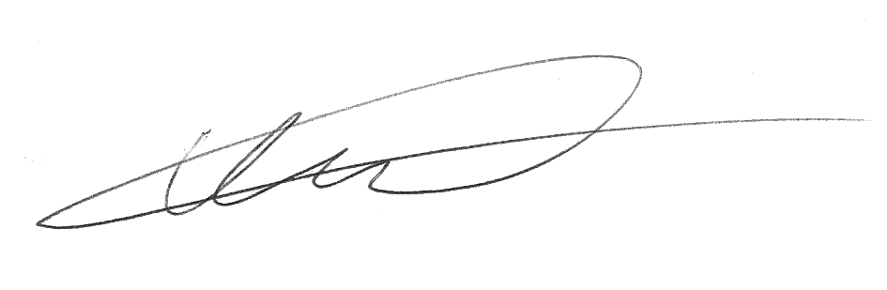
Student Signature | 

